**Practical-5:** Shadow and Blur effect with text tool and alignment properties

**Definition:** Create a blog card design and pricing card design using Alignment, & Distribution, Google & Custom Fonts, Corner Radius, Shadow, Blur Effects, Fill, & Stroke, Text Properties & Styles.

**Solution:**

## 1st Product Card

**2nd Pricing Cards**

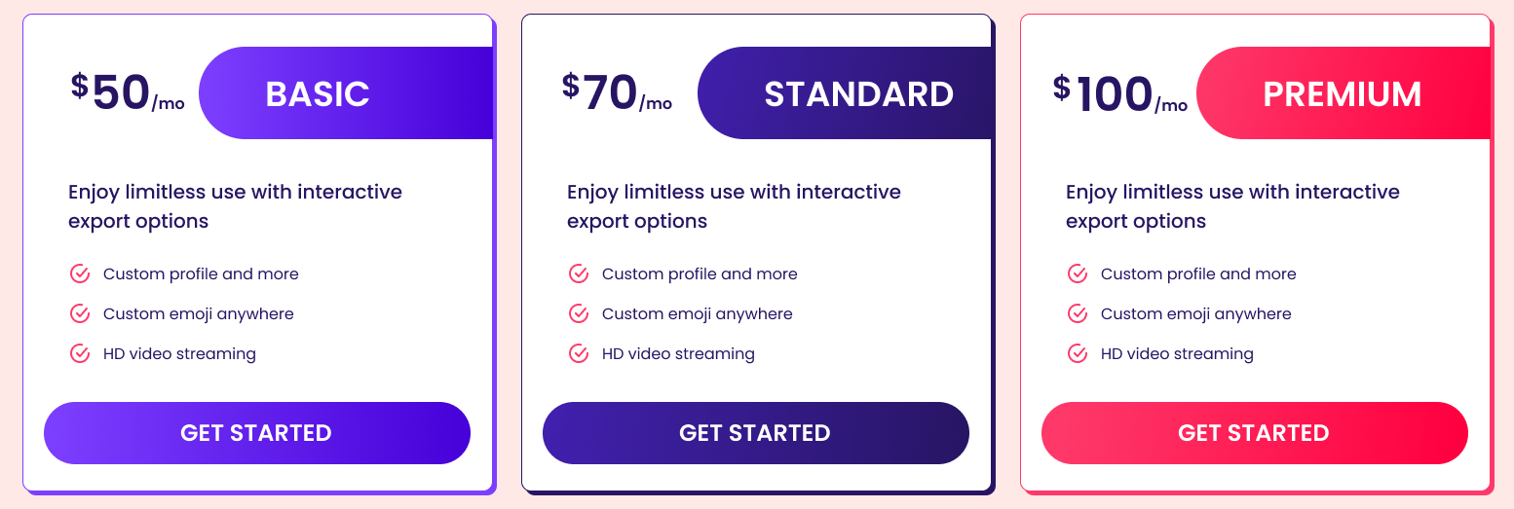

**Working:**

* First, open Figma. Add a new Figma design file.
* Rename a file as 133_Practical-5_Cards_UI
* In this design, the following tools are used for a particular operation:
* Export your design as a PNG file.

1st Product Cards

|  |  |  |
| --- | --- | --- |
| **Tools Name** | **Use** | **Properties** |
| **Frame Tool (F)** | Used as the card container for each shoe product. | Size: 300×380px  Corner radius: ~16-24px  Fill: White (for card) Outer page background: dark grey or black |
| **Rectangle Tool (R)** | Used for the image container area at the top of the card. | Size: 280×200px Corner radius matches top corners Fill: set to “Image Fill” |
| **Image Fill** | To insert the shoe product image inside the rectangle. | Right-click rectangle → Fill → Image Fit the shoe image properly inside the rectangle |
| **Text Tool (T)** | Used for the product name e.g. “Nike Air Max 270.” | Font: Bold or Semi-bold  Size 16-18px  Color: Dark for light cards, white for dark backgrounds |
| **Text Tool (T)** | Used for the year or subtitle below the product name. | Font: Regular Size 12-14px  Color: lighter grey or lower opacity |
| **Text Tool (T)** | Used for brand name e.g. “NIKE.” | Font: Regular Size 12px  Color: lighter grey |
| **Text Tool (T)** | Used for price text like “₹13,995.00.” | Font: Bold Size 16px  Color: strong and visible |
| **Ellipse Tool (O)** | Used to create the floating circular (+) button on the right side. | Size: 40×40px  Fill: dark color or brand color Place “+” icon inside |
| **Vector/Icon Tool** | Used to draw or place the “+” icon in the circle. | Color: white or matching brand color |
| **Auto Layout (Shift + A)** | Helps stack text and button neatly with equal spacing. | Vertical layout Spacing between text blocks 8-12px |
| **Align & Distribute Tools** | Used to keep the cards aligned horizontally with equal gaps. | Horizontal spacing between cards |
| **Layer Rename** | To name layers for clarity and future edits. | E.g. “Card Background,” “Shoe Image,” “Price Text,” “Add Button.” |
| **Export Tool** | To export the design for sharing or uploading. | File → Export → PNG or JPG |

2nd Pricing Cards

|  |  |  |
| --- | --- | --- |
| **Tools Name** | **Use** | **Properties** |
| Frame Tool (F) | Used as the outer container for each pricing card. | Size: 320×450px  Corner radius: 16px  Stroke: 1-2px border in light color (e.g. #E0E0E0) Background fill: white |
| Rectangle Tool (R) | Used for the colored banner shapes behind the plan titles (e.g. “BASIC”, “STANDARD”, “PREMIUM”). | Size: full width of card,  height 50-80px  Corner radius matching card Fill colors: gradients (purple, pink, red) or solid fills |
| Text Tool (T) | Used for plan prices (e.g. “$50 /mo”). | Font size 28-36px  Weight: Bold or Semibold  Color: dark purple or dark grey |
| Text Tool (T) | Used for plan names like “BASIC”, “STANDARD”, “PREMIUM”. | Font size 16-20px  Weight: Bold  Color: white for colored backgrounds |
| Text Tool (T) | Used for description like “Enjoy limitless use with interactive export options.” | Font size 12-14px  Color: #4B4B4B or dark grey |
| Icon Tool / Vector | Used to create or place the tick/check icons beside features. | Size 16×16px  Stroke or fill color: red (#FF4D6D) |
| Text Tool (T) | Used for feature list items like “Custom profile and more.” | Font size 12-14px  Color: #4B4B4B or dark grey |
| Rectangle Tool (R) | Used for “GET STARTED” buttons. | Size: 260×50px  Corner radius 25px  Fill: gradient or solid brand color (purple, pink, etc.) Text color: white |
| Auto Layout (Shift + A) | Helps stack text, price, features, and buttons vertically with even spacing. | Vertical layout Spacing between elements ~12-16px |
| Align & Distribute Tools | Used to keep cards aligned horizontally with equal gaps between them. | Horizontal spacing between cards |
| Layer Rename | Helps organize the layers for easy identification. | Example names: “Pricing Card Basic,” “Price Text,” “CTA Button.” |
| Export Tool | Used to export your finished design as PNG or JPG. | Go to File → Export → PNG or JPG |